- The floor is wet. Your brother is walking on it.
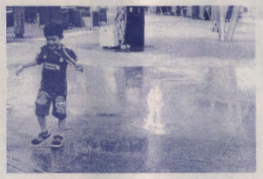
What should you say to him?
1. Be quiet. 2.Hurry up.
3. Be careful. 4. Step down.
- Your friend is in hospital. What should you say to him?
1. Get out. 2. Get ready.
3. Get up now. 4. Get well soon.
- In the classroom
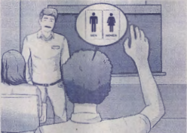
You want to go to the toilet What should you say to your teacher?
1. Can I get up, please? 2. May I go out, please?
3. Can you go up, please? 4. May you get out, please?
- Look at the sign
You can see this sign in _____
1. a library 2. a canteen
3. a restaurant 4. a coffee shop
- In a zoo
Beth: Let's sit on this bench.
Tan: No, we can't. Look at the sign.
Which sign do Beth and Tan see?
1. 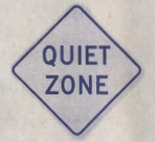 2.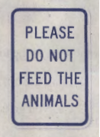
3. 4.
- Your friend gave you this card.
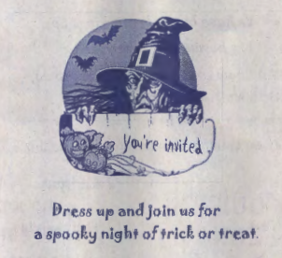
Which party are you invited to?
1. Easter 2. Christmas
3. New Year 4. Halloween
- What do Americans say to their family on February 14?
1. Trick or treat! 2. Merry Christmas!
3. Happy Thanksgiving! 4. Happy Valentine's Day!
- Read the poem.
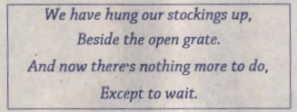
On which holiday do children in some countries do this?
1. Easter 2. Christmas
3. New Year 4. Thanksgiving
- With most meals, Thai people have rice while western people have _________.
1. pizza 2. bread
3. noodles 4. Spaghetti
- Which word has a different vowel sound from "dear"?
1. bear 2. fear
3. hear 4. Year
- Which of the following is correct?
1. Chocolate is in the box of refrigerator.
2. Refrigerator is in the chocolate of box.
3. A box of chocolate is in the refrigerator.
4. The refrigerator is in a box of chocolate.
- Which question has a different intonation from the others?
1. How far is it? 2. How much is it?
3. Have they just left? 4. How many are they?
- Which of the following punctuation marks is not correct?
1. The questions are difficult.
2. The questions are not easy.
3. They cannot answer the questions.
4. Can the students answer the questions.
- The bus had just left when Mike arrived at the bus stop at 2.50 p.m.
Mike: Excuse me. When is the next bus coming?
Woman: It comes every fifteen minutes
When is the next bus?
1. 2.55 p.m. 2. 3.05 p.m.
3. 3.15 p.m. 4. 4.3.30 p.m.
- At school
You throw the glass bottles into this kind of bin. What will happen next?
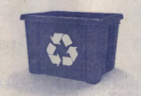
1. They will be burnt. 2. They will be recycled.
3. People will throw them away. 4. People will put them in the trash bin.
- Look at the table.
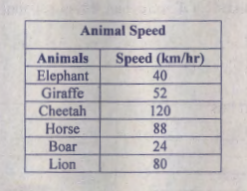
Which sentence is correct?
1. A horse is the fastest.
2. An elephant is the slowest.
3. A lion is faster than a cheetah.
4. A boar is slower than a giraffe.
- There are one hundred and eighty students. Half of them go to school by bus. More students ride a bicycle than walk to school.
Which diagram is correct?
1. 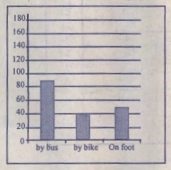 2. 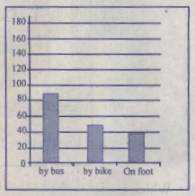
3. 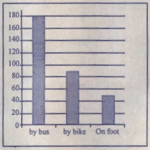 4. 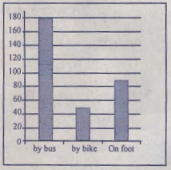
18-19 Look at the map.
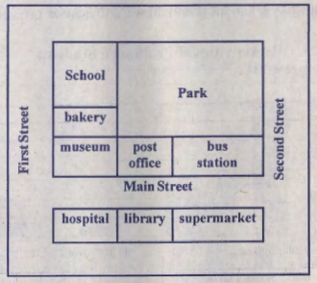
- Which sentence is correct?
1. The hospital is next to the library.
2. The museum is opposite the supermarket.
3. The school is between the park and the bus station.
4. The post office and the bakery are on the same road.
- Sean is at the post office. How can he get to the library?
1. Walk past the park. The library is on the left.
2. Walk along First Street. The library is on the right.
3. Walk across Main Street. The library is in front of him.
4. Walk along Second street. The library is opposite the museum.
20-22 Look at the chart which shows activities each Prathom 6 student does in the morning at school before class, and answer questions 20-22.
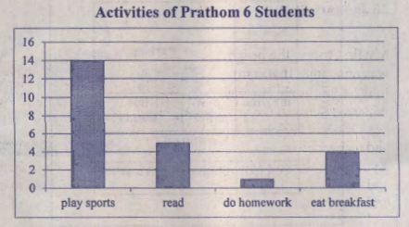
- How many students are there in Prathom 6?
1. Thirty 2. Fourteen 3. Twenty-four 4. Twenty-eight
- What do most of the Prathom 6 students do at school before class in the morning?
1. Play sports 2. Read books
3. Do homework 4. Eat breakfast
- Which of the following is correct?
1. Four students read books.
2. One student eats breakfast.
3. More students eat breakfast than play sports.
4. More students read books than do homework.
23-27 Read Maria's diary and answer the questions.
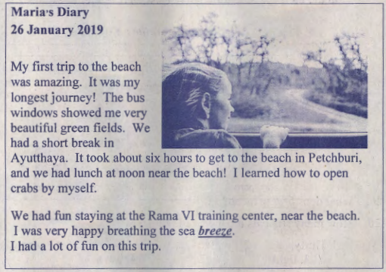
- What is the diary about?
1. Beautiful green fields 2. The beach in Petchburi
3. Maria's longest journey 4. The Rama VI training center
- What time did Maria probably start the journey?
1. 6.00 a.m. 2. 8.00 a.m.
3. 8.00 p.m. 4. 10.00 p.m.
- Which province could be Maria's hometown?
1. Phuket 2. Suratthani
3. Chumphon 4. Phitsanulok
- What does breeze mean?
1. sand 2. wind
3. light 4. Water
- Which sentence is correct?
1. Maria had lunch in Ayutthaya.
2. Maria's house is near the seaside.
3. Maria had new experiences on her trip.
4. The Rama VI training center keeps crabs.
Directions:
Items 28- 40 Choose the best answer to complete the conversations.
- Teacher: ________________
Student: I'm eleven.
1. How old are you?
2. How much do you weigh?
3. How often do you exercise?
4. How many books do you have?
- Mark: _______________
Pang: Thailand
1. What can you do?
2. Why are you going?
3. When do you arrive?
4. Where are you from?
- Samuel: How did you go to the cave?
Wayne: __________________
1. I rode my bike.
2. It was very dark.
3. It was very nice there.
4. I wanted to see the rocks.
- Ping: ____________________
Tek: I like collecting coins. I have a lot in my album.
1. What is your hobby?
2. Where are your coins?
3. Where is your coin album?
4. What is your favorite subject?
- Amy: Let me introduce myself. I'm Amy.
Prim: Hi Amy. I'm Prim.
Amy: _____________________
1. I'm all right.
2. Fine, thank you.
3.·I have to go, bye.
4. Nice to meet you
- In the classroom
Jan: Mary, could I borrow your pen, please?
Mary: ____________ I'm not using it.
1. What?
2. Of course.
3. Never mind.
4. How come?
- In the classroom
Sam: It's hot in here. ____________
Bob: Certainly.
1. How would it be?
2. What is the weather like?
3. What are students doing?
4. Can you turn on the fan, please?
- Doug: Oh, no! It's very heavy. I can't lift it up.
Ethan: ____________________
1. Let me help you.
2. You're very heavy.
3. The lift is over there.
4. Show me your hands.
- Raul: Would you like a drink?
Tony: _____________ I'm very thirsty now.
1. Yes, please.
2. No, thanks.
3. No, I wouldn't.
4. Yes, you would
- This school vacation, Ann is going to Singapore with her family.
Ann: I am leaving for Singapore tomorrow.
Pim: ____________________
1. Well done!
2. You'll be okay!
3. Have a nice trip!
4. Congratulations!
- Ming: Would you like to go to the party tonight?
Chai: I have to do my homework. _______________
1. I'm sorry.
2. I'd love to.
3. You're sorry.
4. You'd like to.
- At a department store
Customer: I'm looking for a shirt.
Assistant: __________________
Customer: Medium, please.
1. How much is it?
2. What color is it?
3. What size do you want?
4. How many shirts do you want?
- Wandee: What do you think about April in Thailand?
Tourist: ___________________________
1. It comes after March.
2. I like it. It's in Thailand.
3. It is not the fourth month.
4. I don't like it. It's too hot.

